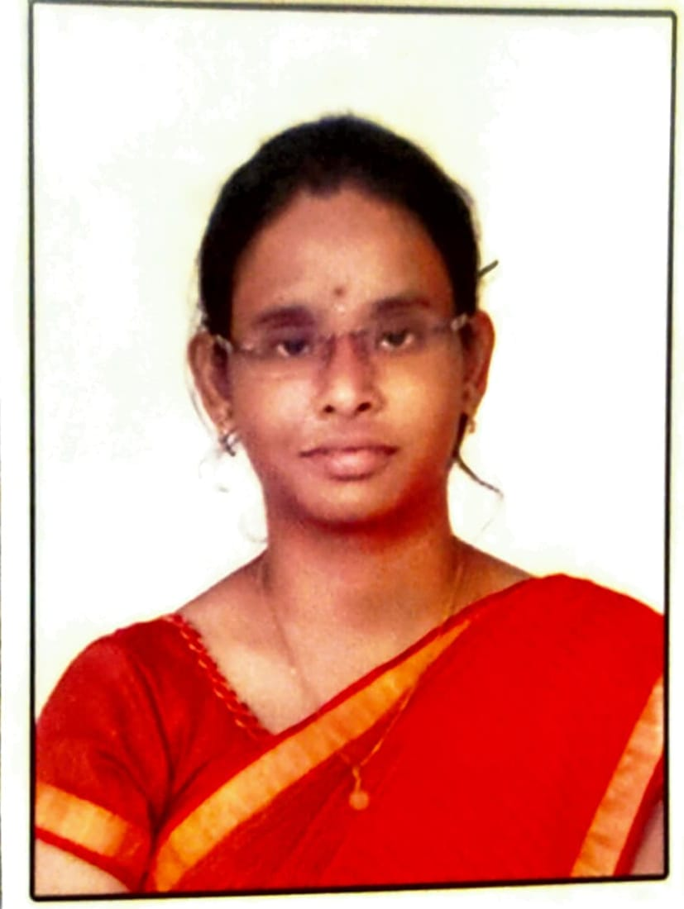RESUME

**T.Indra Deepika**

[E-mail:**deepikaind528**@gmail.com](mailto:hemalatha.9830@gmail.com) **Ph. No:** 7288957515

**Address:** D-No: 16/494-2

Valandapalem Street, Machilipatnam,

Krishna (Dist): 521002

**Career Objective:**

To Obtain any challenging position in your organization that provides an opportunity to gain further exposure and wish to optimally utilize my potential and add value to the organization and myself.

**Educational qualifications:**

|  |  |  |  |  |
| --- | --- | --- | --- | --- |
| **Course** | **Institution** | **University/Board** | **Year** | **Percentage** |
| P.hd  (CSE) | Annamalai University | Annamalai University | 2023 | Pursuing  II year |
| M.Tech (CSE) | Gudlavalleru Engineering College. | Jawaharlal Nehru  Technological University, Kakinada | 2020 | 8.7 |
| B. Tech (CSE) | Sri Vasavi Institute of Engineering and Technology | Jawaharlal Nehru Technological University, Kakinada | 2018 | 7.6 |
| Inter (CSE) | Indrakeeladri Junior College | Board of Internediate Education | 2014 | 7.71 |
| SSC | Navajeevan Public School | Board of Secondary Education | 2012 | 7.3 |

**Work Experience:**

* Working as Assistant Professor in Seshadri Rao Gudlavalleru Engineering College , IT Department, from Nov-2021 to till date.
* 9 Months Experience in VSR Degree college(Movva) as Faculty

# Exposure: Academic Projects

# Title: A Gaussian mixture model and a support vector machine are fused to produce about the facial expression’s

**Description:** his project focuses on facial expression recognition by fusing Gaussian Mixture Models (GMMs) and Support Vector Machines (SVMs). GMMs are used to model the statistical distribution of facial features, capturing subtle variations in expressions, while SVMs act as discriminative classifiers to accurately categorize the expressions into predefined emotional states. The fusion of these models leverages the strengths of both: the generative ability of GMMs and the classification power of SVMs. This hybrid approach improves recognition accuracy and robustness, making it suitable for applications in emotion-aware systems, human-computer interaction, and surveillance.

* Coding Language : Python
* Tool : scikit-learn

# Certificate of Publication:

Journal of Information and Computational Science

ISSN: 1548-7741 Vol-10 , Issue-06 – 2020

**Title: IOT Baesd Smart Gas Monitoring System**

**Description:** The IoT-Based Smart Gas Monitoring System is designed to detect and monitor the presence of harmful gases (such as LPG, methane, or carbon monoxide) in the environment and provide real-time alerts to prevent accidents like gas leaks or explosions. The system uses gas sensors to continuously measure gas concentrations and transmits the data to an IoT platform via Wi-Fi. If the gas level exceeds a predefined threshold, the system triggers an alarm (buzzer or LED) and sends instant notifications to users through a mobile app or web dashboard.

**PROJECTS GUIDED**

1. T.Indra Deepika ,P. Jaswanth, Y. Sai Venkat, SK. Jani Basha, S.Sai Sravan published paper Under the guidance of “ Ms.T.Indra Deepika”, “**Credit Card Fraud Detection Using Deep Learning”** International Research Journal Of Modernizationin Engineering Technology and Science Vol. 07, Issue. 3 : 2025 ISSN :2582-5208
2. T.Indra Deepika, B.Sailaja, Ch.Tarunasri, Ch.Geethika, Durga Surendra Kumar published paper Under the guidance of “ T.Indra Deepika”, **“Prediction of lung cancer using SVM and CNN”.** International Journal of Information Technology and Computer Engineering Vol. 12, Issue. 1 : Mar-2024 ISSN :2347-3657
3. T.Indra Deepika, Shaik Mohmmad Sadiq,M.L.D Prasanna,P.Naga Sweatha, U.Radha Krishna published paper Under the guidance of “ T.Indra Deepika”, **“Skillcorner:A Project based Learning Platform”.**
4. T.Indra Deepika, G.Naresh Babu,M.Krishna Kumari,M.Bhanu Prakash,R.Deepika Santhoshi published paper Under the guidance of “ T.Indra Deepika”, “Google Playstore App Rating Prediction Using Decision Tree Classifier”. A Journal for New Zealand Herpetology Vol. 12, Issue. 2 : 2023 ISSN :2230-5807
5. “**Google Assistant Controlled Home Automation System**” title as a mini project during the period of 2022-2023.

**PAPERS PUBLISHED IN CONFERENCES**

1. “Multi-Model Emotion Recognition from Voice Faceand Text Sources using Optimized Progressive Neural Network:A Literacture Review”, 3rd International Conference on Automation,Computing and Renewable Systems (ICACRS-2024), Organized By Mount Zion College of Engineering and Technology , Pudukkottai, Tamil Nadu .

Conference Date: 04-06 December **2024. (IEEE)**

**LIST OF WORKSHOPS / SEMINARS ATTENDED/FDP:**

* + Attended three-day Online Faculty Development Program on “Generative AI” organized by the Department of Information Technology of Seshadri Technology of Seshadri Rao Gudlavalleru Engineering College, Gudlavalleru from 26 JUN 2024 to 28 JUN 2024.
  + Attended One Week Online Faculty Development Program “Recent Trends in Artificial and machine learning”, seshadri rao gudlavalleru engineering college, organized by the department of CSE , Bonnam Venkata Chalamayya Engineering college 18 JUN 2024 to 22 JUN 2024.
  + Participated One Day National Level Faculty Development Programme on RESEARCH PAPER WRITING USING TOOLS, organized by Research and Development Cell, ACE Engineering College, Hyderabad held on May 10, 2024.
  + Participated in six days FDP on **“MEAN Stack Technologies”** at Seshadri Rao Gudlavalleru Engineering College during6th March – 14th March 2023.
  + Participated FDP on “ **Deep learning for Real Time Research Applications & machine Learning”** at Seshadri Rao Gudlavalleru Engineering College during3rd  Jan 2022 – 7 th Jan 2022.
  + Participated FDP on “ **Challenges And Research Opportunities in Deep Learning And Machine Learning”** at Seshadri Rao Gudlavalleru Engineering College during2nd Jan 2023 – 7 th Jan 2023.
  + Participated in one week online FDP on “**Fullstack Application Development”** at Gudlavalleru Engineering College during 15 th June - 21 st June 2022.
  + Participated in Two week Refresher Course on **“ Computer Networks”** at Gudlavalleru Engineering College during 18 th June - 30 th June 2022.
  + Participated FDP on **“ INSIGHTS OF NEP 2020 AND STRATEGIES FOR ITS IMPLEMENTATION”** at Gudlavalleru Engineering College on 12 th June 2022.

# Extra Curricular Activities:

* Organized Two Days sdp on “**Web Design Using AI Tools**” was conducted on 7th Nov to 8th Nov 2024, 260 students from I B.Tech were participated in this program.
* Organized Three Days Student Develop Program on “**Game Design Using Build box**” was conducted on 20th March to 22nd March 2024, **Mrs. Y. Revathi Devi,** Apssdc, acted as resource person. 70 students from I B.Tech were participated in this program.

# Technical Skills:

Programming Languages : C , DS

DataBase : SQL

Web Technologies : HTML

# Skills:

* Adobe Photoshop
* MS Office
* Computer Hardware & Software Troubleshooting

**Achievements:**

* + Received Second prize in the Technical Quiz held at Gudlavalleru Engineering College.
  + Received First Prize in Essay Writing Competition in my School.

# Strengths:

* Creative and quick learning highly committed to goal accomplishments, willing to accept responsibility, dedicated, hard-working and possesses good Communication skills with positive attitude.

# Personal Details:

Name : Thota Indra Deepika

Father Name : Thota Venkata Subrahmanyeswara Rao

Date of Birth : 26-10-1996

Marital Status : Single

Nationality : Indian

Languages Known : Telugu, English & Hindi

# Declaration:

I hereby declare that the information furnished above is true and correct to the best of my knowledge and belief.

# Place :

**Date : (T.Indra Deepika)**